1. Which of the following statements for a simple graph is correct?  
a) Every path is a trail  
b) Every trail is a path  
c) Every trail is a path as well as every path is a trail  
d) Path and trail have no relation  
View Answer

Answer: a  
Explanation: In a walk if the vertices are distinct it is called a path, whereas if the edges are distinct it is called a trail.

2. In the given graph identify the cut vertices.  
[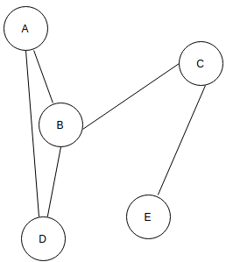](https://www.sanfoundry.com/wp-content/uploads/2017/08/data-structure-questions-answers-graph-q2.png)  
a) B and E  
b) C and D  
c) A and E  
d) C and B  
View Answer

3. For the given graph(G), which of the following statements is true?  
[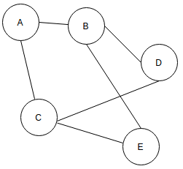](https://www.sanfoundry.com/wp-content/uploads/2017/08/data-structure-questions-answers-graph-q3.png)  
a) G is a complete graph  
b) G is not a connected graph  
c) The vertex connectivity of the graph is 2  
d) The edge connectivity of the graph is 1  
View Answer

4. What is the number of edges present in a complete graph having n vertices?  
a) (n*(n+1))/2  
b) (n*(n-1))/2  
c) n  
d) Information given is insufficient  
View Answer

5. The given Graph is regular.  
[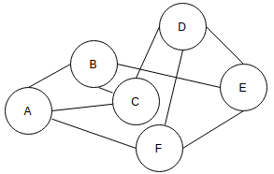](https://www.sanfoundry.com/wp-content/uploads/2017/08/data-structure-questions-answers-graph-q5.png)  
a) True  
b) False  
View Answer

**Join Sanfoundry@YouTube**

6. In a simple graph, the number of edges is equal to twice the sum of the degrees of the vertices.  
a) True  
b) False  
View Answer

Answer: b  
Explanation: The sum of the degrees of the vertices is equal to twice the number of edges.

7. A connected planar graph having 6 vertices, 7 edges contains _____________ regions.  
a) 15  
b) 3  
c) 1  
d) 11  
View Answer

Answer: b  
Explanation: By euler’s formula the relation between vertices(n), edges(q) and regions(r) is given by n-q+r=2.

8. If a simple graph G, contains n vertices and m edges, the number of edges in the Graph G'(Complement of G) is ___________  
a) (n*n-n-2*m)/2  
b) (n*n+n+2*m)/2  
c) (n*n-n-2*m)/2  
d) (n*n-n+2*m)/2  
View Answer

Answer: a  
Explanation: The union of G and G’ would be a complete graph so, the number of edges in G’= number of edges in the complete form of G(nC2)-edges in G(m).

9. Which of the following properties does a simple graph not hold?  
a) Must be connected  
b) Must be unweighted  
c) Must have no loops or multiple edges  
d) Must have no multiple edges  
View Answer

Answer: a  
Explanation: A simple graph maybe connected or disconnected.

10. What is the maximum number of edges in a bipartite graph having 10 vertices?  
a) 24  
b) 21  
c) 25  
d) 16  
View Answer

Answer: c  
Explanation: Let one set have n vertices another set would contain 10-n vertices.  
Total number of edges would be n*(10-n), differentiating with respect to n, would yield the answer.

11. Which of the following is true?  
a) A graph may contain no edges and many vertices  
b) A graph may contain many edges and no vertices  
c) A graph may contain no edges and no vertices  
d) A graph may contain no vertices and many edges  
View Answer

Answer: b  
Explanation: A graph must contain at least one vertex.

12. For a given graph G having v vertices and e edges which is connected and has no cycles, which of the following statements is true?  
a) v=e  
b) v = e+1  
c) v + 1 = e  
d) v = e-1  
View Answer

Answer: b  
Explanation: For any connected graph with no cycles the equation holds true.

13. For which of the following combinations of the degrees of vertices would the connected graph be eulerian?  
a) 1,2,3  
b) 2,3,4  
c) 2,4,5  
d) 1,3,5  
View Answer

Answer: a  
Explanation: A graph is eulerian if either all of its vertices are even or if only two of its vertices are odd.

14. A graph with all vertices having equal degree is known as a __________  
a) Multi Graph  
b) Regular Graph  
c) Simple Graph  
d) Complete Graph  
View Answer

Answer: b  
Explanation: The given statement is the definition of regular graphs.

15. Which of the following ways can be used to represent a graph?  
a) Adjacency List and Adjacency Matrix  
b) Incidence Matrix  
c) Adjacency List, Adjacency Matrix as well as Incidence Matrix  
d) No way to represent  
View Answer

Answer: c  
Explanation: Adjacency Matrix, Adjacency List and Incidence Matrix are used to represent a graph